Research on Mechanical Sensitivity Response Prediction of Explosives Based on Machine Learning

Fanghao Yao¹, Xiongzhu Bu^{1*}, Liangzheng Ding¹, Xinhao Huang¹, Zouzou Zhang²
¹Nanjing University of Science and Technology, School of Mechanical Engineering
Nanjing, Jiangsu, China
²Xi'an Modern Chemistry Research Institute
Xi'an, China
* Corresponding author: buxu105@njust.edu.cn

Abstract—In order to reduce the workload and uncertainty of conventional mechanical sensitivity tests of explosives, and to obtain the performance parameters of explosives more quickly and accurately, machine learning methods to predict the response values of explosives mechanical sensitivity is proposed. The dataset is constructed by real test, finite element simulation and Monte Carlo data enhancement. By training and hyperparameter tuning for different classification models, we conclude that BP neural network is the best. The model is tested with real test data, and the results show that it is effective and feasible to predict the response values of mechanical sensitivity. It also provides a good reference for multiple QMU (quantification of margins and uncertainties) reliability evaluation of explosives.
Keywords-machine learning; explosive; safety; QMU evaluation

Introduction
The degree of explosion of explosives under mechanical action is called mechanical sensitivity, including impact sensitivity and friction sensitivity. Bruceton up-down method is widely used in the sensitivity test of products. Due to the limitations of the development period and cost of this method, and the insufficient experimental samples and data required [1], the results are highly stochastic and traditional methods cannot achieve accurate predictions. In recent years, machine learning is uniquely superior in solving nonlinear problems with uncertain inference rules. It has also been applied in the prediction of performance parameters of fire explosives
Reference [2] proposed hessian local linearly embedding (HLLE) algorithm based on SVM. The prediction accuracy of composite explosion parameters exceeds more than 95%. Reference [3] indicated that artificial neural network is obviously superior to multiple linear regression for the prediction of impact sensitivity of compounds. Reference [4] realized the prediction of explosive critical performance based on genetic-neural network with smaller error and better effect.
Back-propagation neural-based genetic algorithm for the calibration of Jones-Wilkins-Lee equal of state parameters of explosive [5] was proposed, the introduction of this method can simplify the optimization process and the test data have proved its high accuracy [6] [7]. Subsequently, the fuel air explosives cloud detonation models can be established.
As few reports on the prediction of the response values of explosives mechanical sensitivity have been seen, this paper combines real test, finite element simulation and Monte Carlo data enhancement [8], builds a suitable machine learning model. The ultimate goal is to input the stimulus amount of impact and friction sensitivities that can quickly and accurately predict the response outcome. This method reduces the amount and consumption of tests and provides a basis for QMU reliability evaluation of explosives.

Mechanical Sensitivity Response Prediction Model

Source and construction of the dataset
Experimental data: According to the national military standard in "GJB772A-1997" (601.2 characteristic drop height method & 602.1 explosion probability method) [9], the determination of impact and friction sensitivity of some kind of explosives are carried out. The impact sensitivity and the logarithmic values of drop height satisfy normal distribution. Giving initial stimulus and step size, and five groups with 125 shots of Bruceton up-down method experiments were performed with falling hammer. The swing hammer of pendulum friction instrument hits the sample of explosives to be measured with the standard pendulum angle and gauge pressure. Two groups with 50 shots of tests were conducted. If the sample is found to be audible, glowing, decomposing and smoking in the above tests, we can judge it as an explosion, i.e, response. The experimental apparatus are shown in Fig.1.
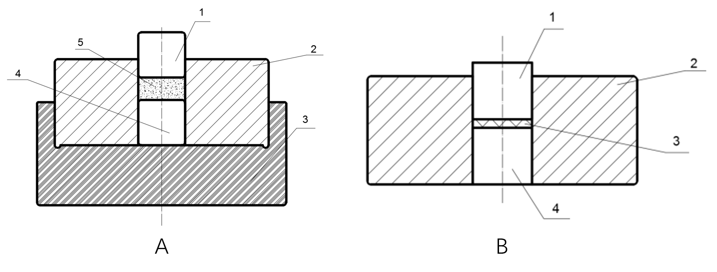
Figure1. Impact sensitivity test (A): 1-Upstroke column, 2-Strike sleeve, 3-Base, 4-Downstroke column, 5-Sample. Friction sensitivity test(B): 1-Upslide column, 2-Sliding sleeve, 3- Sample, 4-Downslide column.
Finite element simulation: ANSYS AUTODYN software was used to simulate the sensitivity tests of explosive particles. Models of drop hammer impacting HMX explosive particles and pendulum impacting slide column were established. Subsequently, we simulated the characteristic drop height method and explosion probability method introduced above. The particle diameters used for the simulation were mixed from 200 to 400 μm. Simulations of the impact sensitivity tests were performed at drop heights of 15.8 to 39.8 cm to observe the response results. Simulations of the friction sensitivity tests were conducted with samples actually subjected to pressures of 85-480 MPa and pendulum swing angles of 30-90° to observe the reaction degree at different pressures and swing angles. The simulation results are shown in Fig. 2.
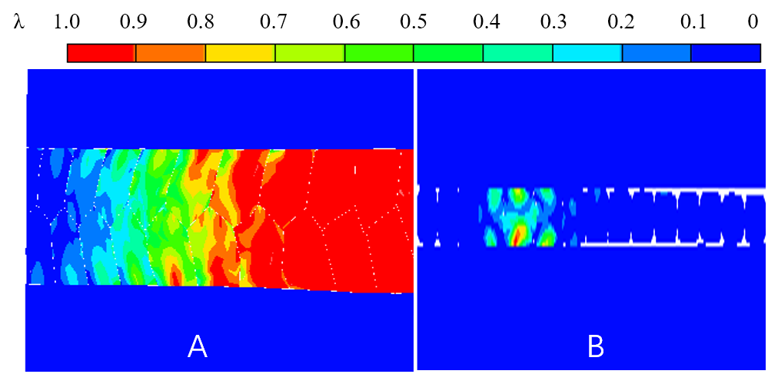
Figure 2. Impact (A) and friction (B) sensitivity simulations, λ means the percentage of response
Monte Carlo simulation data enhancement: The program flow is shown in Fig. 3. The principle of the computer simulation of sensitivity tests is that the program randomly generates a critical stimulus amount and compares it with another group of stimuli generated according to the standard to obtain the response results [8]. In order to expand the dataset of explosive sensitivity tests, Monte Carlo program is written to simulate Bruceton up-down method. μ and σ of the critical stimulus quantities obtained from real tests and simulations as a priori knowledge [10]. Determine the initial stimulus x₁ as μ step size d as σ. Generate long-period normal random numbers _{xci}~(μ, σ) based on Box-Muller transform. Compare the simulated stimulus x_{i} with _{xci}. If x_{i} is less than _{x}ci , response y_{i} is noted as 0, x_{i+1} is added to xi with step d. Conversely, y_{i} is noted as 1, x_{i+1} is subtracted from xi by step d. It stops until the sampling number reaches N. An example of the simulation is shown in Fig.4 used by MATLAB.
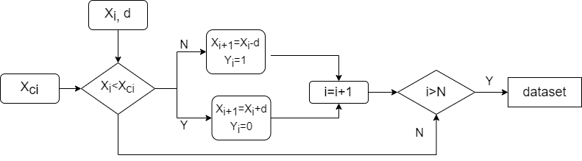
Figure 3. Algorithm of computer simulation up-down method
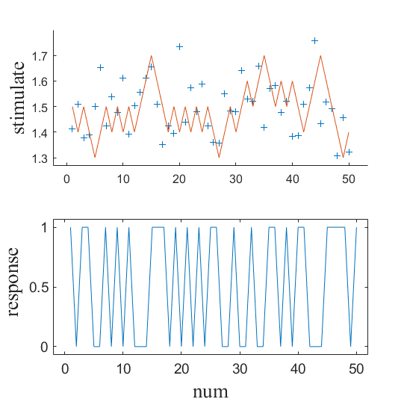
Figure 4. Example of the simulation results
Composition of the dataset: Two parts of the data generated by finite element and Monte Carlo simulation are combined, randomly disrupted and divided into training, validation and test sets. The real sensitivity test data are retained for the final prediction. The composition of the dataset required to train the model is shown in Table I.
- Composition of The Dataset

Build model
Type | Number of each type |  |  | Input | Output
Type | Real test | Finite element | Monte Carlo | Input | Output
Impact | 125 | 250 | 450 | Particle diameter, Drop height | Stimulus  (0 or 1)
Friction | 50 | 64 | 190 | Particle diameter, Pressure, Pendulum angle | Stimulus  (0 or 1)

Model training
There are two phenomena in the mechanical sensitivity tests of explosives. We note explosive as 1 and inexplosive as 0. Therefore, the prediction of response values can be considered as a binary classification problem. The following eight classification models are selected:
(A) Fine decision tree. It improves learning efficiency by decision tree pruning, but is sensitive to data noise.
(B) Logistic regression. It has highly interpretative but performances not so good for complex data.
(C) Kernel naive bayes. The generalization effect of limited data is good. However, the input variables should be assumed to be independent of each other.
(D) Quadratic support vector machine. It searches for the maximum margin hyperplane to partition dataset but is sensitive to abnormal data.
(E) Cosine K nearest neighbor. It avoids the problem of sample imbalance according to the majority classification of nearest K samples. But it has high complexity of calculation.
(F) Weighted K nearest neighbor. It makes use of a neighbor weighting function for the purpose of assigning a class to an unclassified sample. But it requires a lot of memory.
(G) Integrated RUS-Boosted tree. It's an ensemble learning method and its performance of processing unbalanced data is relatively robust. But the calculation speed is slow.
(H) BP (back-propagation) neural network. It is composed of input layer, hidden layer and output layer. As it optimizes the model based on the principle of back propagation, it runs faster and has higher accuracy than method (A)-(G).
The training models adopt 10-fold cross validation. After several hyper-parameter tuning, the training results and model information are obtained as shown in Table II and Table III. The results show that the BP neural network have the best performance.

- Model of Impact Test
Model | Accuracy (%) | Precision (%) | Recall (%) | AUC | Training time(s) | Details
A | 71.9 | 72.6 | 68.6 | 0.79 | 1.49 | Maximum split: 100; Principle of division: gini impurity
B | 71.4 | 67.9 | 73.7 | 0.80 | 11.21 | Loss function: binary cross entropy
C | 71.4 | 70.3 | 73.7 | 0.78 | 9.34 | Gaussian kernel
D | 71.4 | 70.3 | 73.7 | 0.79 | 21.48 | Quadratic kernel function
E | 72.7 | 77.3 | 64.5 | 0.79 | 0.95 | Number of neighbors K=19; Metric: cosine distance
F | 73.8 | 74.5 | 72.5 | 0.81 | 0.73 | Number of neighbors K=27; Metric: euclidean distance
G | 72.7 | 69.8 | 78.6 | 0.81 | 5.69 | Maximum split: 100; Learning rate:0.1
H | 88.0 | 84.6 | 91.7 | 0.90 | 0.07 | Hidden layers:10; Sigmoid; MSE; Epochs:14; Bayesian regularization
- Model of Friction Test
Model | Accuracy (%) | Precision (%) | Recall (%) | AUC | Training time(s) | Details
A | 83.9 | 83.2 | 88.4 | 0.88 | 1.85 | Maximum split: 100; Principle of division: Gini impurity
B | 71.7 | 81.8 | 72.9 | 0.78 | 4.10 | Loss function: binary cross entropy
C | 67.7 | 86.5 | 67.4 | 0.75 | 5.35 | Gaussian kernel
D | 80.7 | 79.7 | 86.1 | 0.89 | 43.26 | Quadratic kernel function
E | 83.1 | 87.2 | 83.1 | 0.87 | 46.74 | Number of neighbors K=10; Metric: cosine distance
F | 84.6 | 89.8 | 83.1 | 0.91 | 1.05 | Number of neighbors K=14; Metric: Euclidean distance
G | 85.0 | 89.9 | 83.8 | 0.91 | 5.51 | Maximum split: 40; Learning rate:0.1
H | 88.2 | 91.4 | 91.4 | 0.92 | 0.31 | Hidden layers:30; Sigmoid; MSE; Epochs:62; Bayesian regularization

Prediction of model
- Predict Results
Type | Number of data | Model | Accuracy (%) | Precision (%) | Recall (%) | Binary cross entropy
Impact | 125 | BP neural network | 88.0 | 90.5 | 89.3 | 0.0490
Friction | 50 | BP neural network | 86.0 | 92.5 | 90.2 | 0.0446

Two BP neural network models trained above are selected to predict the response values of the real sensitivity test. Table IV. show that our attempt is effective.

Application Of Model In QMU Evaluation

The definition of QMU
Quantification of margins and uncertainties (QMU) method was presented by LNNL and LANL as a creditability evaluation method which can also be used in reliability certification of systems such as high-tech weapons. The mathematical formula of QMU [11] is：
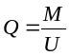 (1)
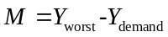 (2)
M is the best estimate of the margin of the performance parameter and is the subtraction of the worst-case estimate for explosives and the estimate for the lowest requirement (failure criterion). U is the uncertainty of M. The calculation methods for M and U are based on specific tests. Q is the confidence coefficient, which is used to characterize whether the explosive meets the reliability requirements. The key elements of QMU are shown in Fig. 5.
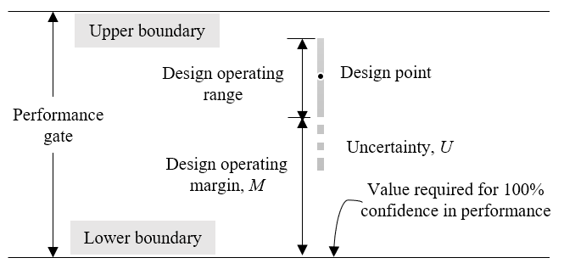
Figure 5. Key elements of QMU

Model prediction and the multiple QMU evaluation
The QMU method shown above is for single performance parameter. However, the QMU evaluation of mechanical sensitivity of explosives is composed of two parameters including impact and friction sensitivity. We proposed a new multiple QMU evaluation methods based on Euclidean distance of projection curve. The performance curve is shown in Fig. 6. According to the trained model, we predict the response value of sensitivity tests. The model of sensitivity and critical stimulus is established from a large number of predicted values as the performance gate in QMU evaluation system. X_{th} is the performance threshold. X_{PL} is the lower limit of the uncertainty of the performance threshold according to the one-sided confidence interval. X₀ is the safety design value. The Euclidean distance between curves is calculated as margin M and uncertainty U.
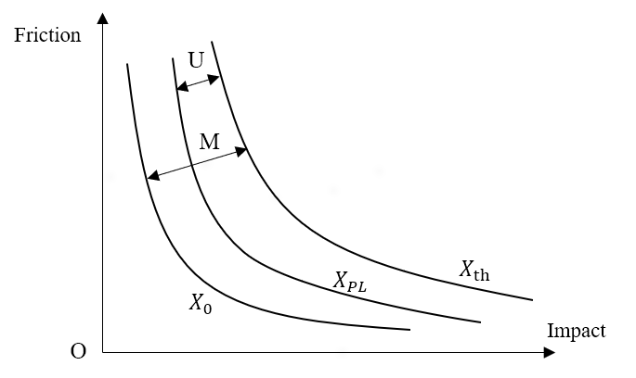
Figure 6. Performance curve of the multiple QMU evaluation
Assume that under the given condition, the safety design value of impact sensitivity is x₁, the one-sided confidence limit is x₂, the critical stimulus is x₃. The safety design value of friction sensitivity is y₁, the one-sided confidence limit is y₂, the critical explosion probability is y₃. This leads to the following equations for the margin and uncertainty in the multiple QMU evaluation method:
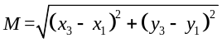 (3)
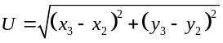 (4)
M is divided by U as the interval range of Q. If Q>1, the uncertainty is included in the margin of performance. We believe that under the given confidence level, the explosive satisfies the reliability requirement that the probability of response does not exceed the safety design value. On the contrary, if there is Q<1, the explosive loses its efficiency.
Taking some explosives for example, predict the response values of 25 impact tests and 50 friction tests by the above trained BP neural network. According to the statistics method [12], when the confidence level is 0.9999, the logarithm value of critical stimulus of impact sensitivity is 1.1662, the lower confidence limit is 0.7157, and the safety value is 0.7. The critical explosion probability of friction sensitivity is 0.6920, the lower confidence limit is 0.6039, and the safety value is 0.6. Calculated from (3)(4), the results are shown in Table V. This multiple QMU method can be extended to higher dimensional Euclidean distance for more sensitivity performance parameters.
- An Example of Multiple QMU Evaluation
 | X_{th} | X_{PL} | X₀
Impact | 1.1662 | 0.7157 | 0.7
Friction | 0.6920 | 0.6039 | 0.6
Multiple evaluation | 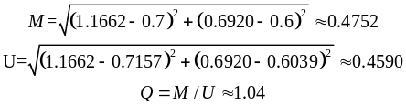  Meet reliability requirements.

Counclusion
According to the results of various model training and prediction, we find that it is feasible to predict the response values of mechanical sensitivity of explosive based on machine learning method. Compared with the conventional sensitivity test method, models of machine learning are faster and have higher accuracy, which can effectively reduce the workload and risk of tests. At the same time, the predicted response values provide an effective reference for the establishment of threshold model of critical explosive sensitivity and multiple QMU evaluation. This research is of great significance to the production, transportation and use of explosives.
Acknowledgment
This work was supported by the Open Cooperation Fund Project of Xi'an Modern Chemistry Research Institute (project number: SYJJ200312).
References
- N. Yan, R. Cai et al., Monte Carlo simulation method and analysis for sensitivity tests, Initiators & Pyrotechnics, 4:1-6, 1995.
- X. Wei, S. Chang et al., Prediction of the composite explosion parameters by HLLE-SVM, Chinese Journal of Energetic Materials, 22(02):221-225,2014.
- B. Qian et al., Prediction of impact sensitivity of polynitro compounds by artificial neural network based on the genetic algorithm, Chinese Journal of Energetic Materials, 24(7):644-650, 2016.
- G. Yu et al., Application research of genetic-neural network method in the performance prediction of explosive, Liaoning Chemical Industry, 48(7):672-675, 2019.
- H. Cui et al., Calibration of JWL parameters of explosive by BP neural network and cylinder energy model, Chinese Journal of Explosives & Propellants, 44(5): 665-673, 2021.
- H. Cui et al., Determination of parameters of JWL equation of state for unreacted explosives based on BP-GA algorithm, Chinese Journal of Energetic Materials, 30(1):43-49, 2022.
- X. Zhao et al., Parameters calculation of JWL EOS of FAE Detonation Products, Acta Armamentarii, 41(10):1921-1929, 2020.
- R. Cai, and Y. Tian, Study of computer simulation of sensitivity experiments, Journal of Wuhan University of Technology (Information & Management Engineering), 3: 64-67, 2003.
- Commission of Science, Technology and Industry for National Defense, GJB772A-97.Explosive test method, Beijing, 1997.
- D. Fu et al., Study on estimation accuracy of the interval estimation method for up-and-down sensitivity test data, in Proceedings of the 6th Symposium on Energetic Materials and Insensitive Munitions, 397-400, 2014.
- Z. Ma, Y. Ying et al., QMU certifying method and its implementation, Nuclear Science and Engineering, 29(1):1-9, 2009.
- C. Hua, S. Zhang et al., QMU evaluation of explosive safety under shock wave effect, Chinese Journal of Explosives & Propellants, 38(4): pp.31-34+62, 2015.

